1. Write a program to read in two integers and perform the following operations on them: addition, subtraction, multiplication, division, and modulo.

Program:

#include<iostream>

using namespace std;

int main()

{

int n1,n2;

cout<<"enter n1:"<<"\n";

cin>>n1;

cout<<"enter n2:"<<"\n";

cin>>n2;

cout<<"sum = "<<n1+n2;

cout<<"\n"<<"diff = "<<n1-n2;

cout<<"\n"<<"mul = "<<n1*n2;

if(n2==0)

cout<<"\nzero error";

else

cout<<"\n"<<"div = "<<static_cast<float>(n1)/n2;

if(n2==0)

cout<<"\nzero error";

else

cout<<"\n"<<"modulo = "<<n1%n2;

return 0;

}

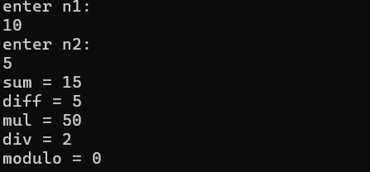Sample Input Output:

1. Program to determine the integer is odd or even

Program:

#include<iostream>

using namespace std;

int main()

{

int n;

cout<<"enter a num: ";

cin>>n;

if (n%2==0)

{

cout<<"even";

}

else

{

cout<<"odd";

}

return 0;

}

Sample Input Output:

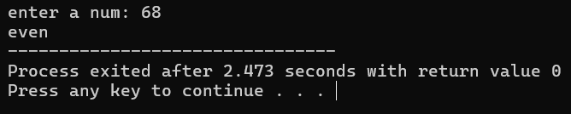

1. Program to compute the average of three integers

Program

#include<iostream>

using namespace std;

int main()

{

int n1,n2,n3;

cout<< "enter n1:";

cin>>n1;

cout<< "enter n2:";

cin>>n2;

cout<< "enter n3:";

cin>>n3;

float avg=static_cast<float>(n1 + n2 + n3) / 3;

cout<<"average = "<<avg;

return 0;

}

Sample Input Output:

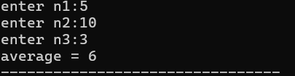

1. Program to check two numbers are equal or not

Program:

#include<iostream>

using namespace std;

int main()

{

int n1,n2;

cout<<"enter n1: ";

cin>>n1;

cout<<"enter n2: ";

cin>>n2;

if(n1==n2)

{

cout<<"equal nums";

}

else

{

cout<<"not equal nums";

}

return 0;

}

Sample Input Output:

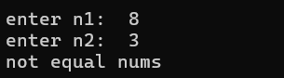

1. Write a program to read in two Floating numbers and perform the following operations on them: addition, subtraction, multiplication, division, and modulo.

Program:

#include<iostream>

using namespace std;

int main()

{

float n1;

float n2;

cout<<"enter n1: ";

cin>>n1;

cout<<"enter n2: ";

cin>>n2;

cout<<"sum = "<<n1+n2;

cout<<"\n"<<"diff = "<<n1-n2;

cout<<"\n"<<"mul = "<<n1*n2;

cout<<"\n"<<"div = "<<n1/n2;

return 0;

}

Sample Input Output:

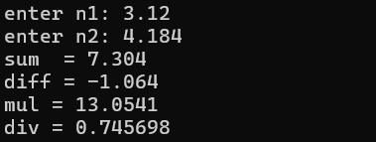

1. Program to check the character is a vowel or consonant

Program:

#include<iostream>

using namespace std;

int main()

{

char c;

string vow = "AEIOUaeiou";

cout<<"enter a character: ";

cin>>c;

int i,flag=0;

for(i=0;i<vow.length();i++)

{

if(c==vow[i])

flag=1;

}

if (flag==1)

cout<<"vowel";

else

cout<<"consonent";

return 0;

}

Sample Input Output:



1. Program to check the number is positive, negative or zero

Program:

#include<iostream>

using namespace std;

int main()

{

int n;

cout<<"enter a integer: ";

cin>>n;

if(n==0)

cout<<"n is equal to zero";

else if(n<0)

cout<<"n is a negative num";

else

cout<<"n is a positive num";

return 0;

}

Sample Input Output:



1. Program to determine which number is greater among two integers

Program:

#include<iostream>

using namespace std;

int main()

{

int n1,n2;

cout<<"enter a num1: ";

cin>>n1;

cout<<"enter a num2: ";

cin>>n2;

if(n1>n2)

cout<<"n1 is greater";

else

cout<<"n2 is greater";

return 0;

}

Sample Input Output:

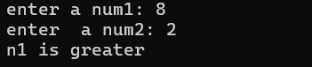

1. Program to read a floating-number and round it to the nearest integer using the floor an ceil functions.

Program:

#include<iostream>

#include<cmath>

using namespace std;

int main()

{

float n;

cout<<"enter a decimal num: ";

cin>>n;

int f=static_cast<int>(floor(n+0.5));

int c=static_cast<int>(ceil(n-0.5));

cout << "Original number: " << n << "\n";

cout << "Rounded to nearest integer (using floor): " << f << "\n";

cout << "Rounded to nearest integer (using ceil): " << c << "\n";

return 0;

}

Sample Input Output:

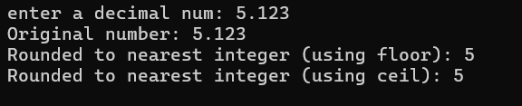

1. Program to swap two numbers using bitwise XOR operator

Program:

#include<iostream>

using namespace std;

int main()

{

int n1,n2;

cout<<"enter 2 nums: ";

cin>>n1>>n2;

cout<<"before swapping n1 = "<< n1 <<" n2 = "<<n2;

n1=n1+n2;

n2=n1-n2;

n1=n1-n2;

cout<<"\nafter swapping n1 = "<<n1<<" n2 = "<<n2;

return 0;

}

Sample Input Output:

